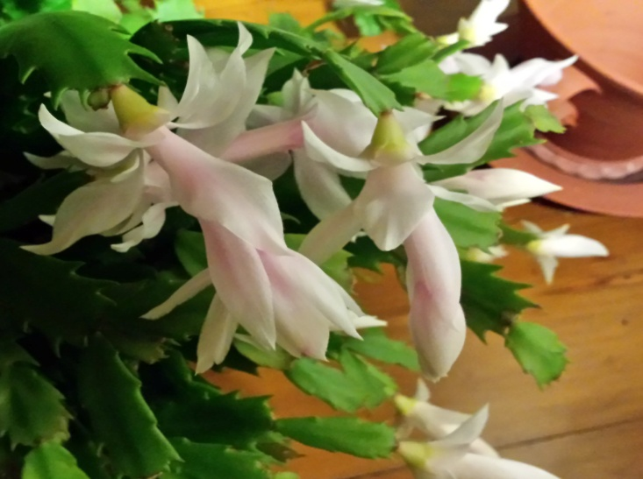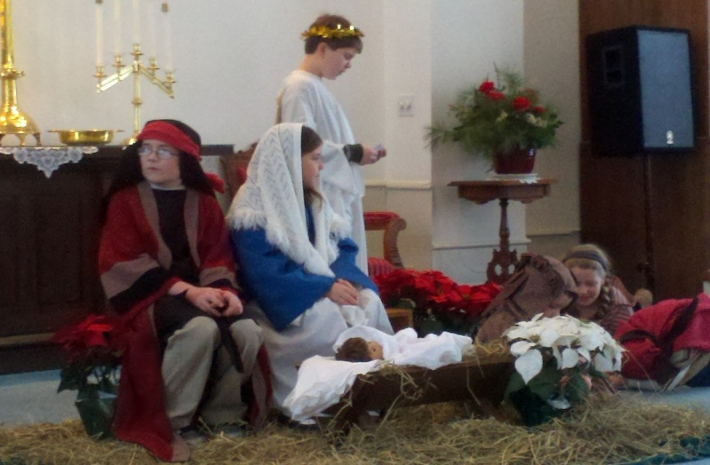
ADVENT 2017
Welcome to another season of Advent. Christians over the years can easily take it for granted because of repetition. We are a species easily distracted and always looking for novelty. There will be many opportunities to experience and remember the special moments which surround us in this season of Advent. It's not just a matter of feeling like the secular has taken over the sacred. Sometimes we try so hard we use up our own resources. We become fatigued and even cynical. Advent becomes the “same old, same old," instead of a beautiful opportunity offered us as Christians to renew our relationship with the gift of this very human birth.
Remember the wonder and the joy you have experienced at any birth, your own child, a grandchild. Now think of the special importance of this birth of the Christ child.
We will have four weeks of preparation before Christmas. Hope, Peace, Love, and Joy will be reignited with the candles on the Advent wreath we will enjoy during Sunday worship. I hope you will consider worship with your faith community as a necessary part of your schedule. It is after all, the heart of this season.
Take time to pray. God is always speaking. And during these four weeks you will have the gift of taking the time to listen. You can do this even as you make those baked goods or wrap those presents.
During Advent take time to study. This might be as simple as re-reading the birth event in the Gospels.
Let the child in you look at this season again. It is easy to do if you have children around you. But, even if there are no youngsters, you are always a "child of God."
Pay attention. During Advent we do not just come toward the close of the year. This season gives us the gift of being able to pay more attention to God's love and providence in your life and in the world.
Remember, the Christ child was born during a tense period too.
We are all humbled and blessed by this season before us. Pastor Veronica Walsh Don

Upcoming Events
- Stewardship time at Mason Church November/December This month you are encouraged to make a monetary pledge for 2018 to Mason Church. Your pledge makes the job of planning a budget possible. Imagine trying to pay your own expenses without knowing how much money you actually have? Pledge cards are available at the table in the sanctuary, or from Darrell Scott, Treasurer. See stewardship letter at the end of newsletter.
- First Sunday of Advent is Dec 3. We will have our tree to decorate, greens to decorate our holy sanctuary, hot chocolate and treats for this special day of Advent—the beginning of the waiting.
- Cecelia Chorus Holiday Concert In Keene at the Redfern Center on Keene State Campus at 3pm or in Peterborough Unitarian Church at 3 pm on Dec 3. Join our own Damery family as they applaud daughter Mahala who participates in this wonderful chorus of young women.
- Mission: Nashua Soup Kitchen, Dec 9. Call Kathy Chapman to let her know if you plan on coming since we can’t bring too many people, but need enough! Meet in the parking lot of the church at 3pm for carpooling. This is a mission open to all. Invite a friend or neighbor, and you may open an opportunity for another caring person. Call 878-4993 or email Kathy at chapman.kathy@gmail.com.

- Living Room Coffee House December 9th 6:30 to 9 or so. Live Music in Mason! Doors open at 6:30, signups for open mic, and snacks are available, with coffee. The Wicked Good Old Boys will be treating us to some beautiful classical tunes, along with their jolly commentary, and the Coffee House Open Mic participants will keep you entertained as well. All are welcome. Bring children and anyone who likes music! Livingroomcoffeehouse.org
- Community Supper December 14, 2017 5:30 to 7pm Join this sociable dinner of Turkey Tetrazzini and all the trimmings. Bring a friend, or reach out to a new neighbor. Gluten free, dairy free vegetarian alternative available as well. Just ask us when you come.
- Conversations with Women Friday December 15 2-4pm Join this wisdom circle of women for lively conversations on a variety of topics. This month I have an article on Wisdom Circles for our discussion. Bring your knitting if you like. Open to all women, everywhere.
- Caroling Sunday with Luncheon, December 17th at 12 noon to 2pm. Join in the songs and the luncheon. Come, celebrate this season as you raise your voice in song, or just listen and enjoy a meal. Bring a friend, open to everyone. Need a ride? Call 878-1684 and ask Pastor Veronica, or leave a message.
- 4 Sundays of Advent—A time to celebrate “People of our time are losing the power of celebration. Instead of celebrating we seek to be amused or entertained. Celebration is an active state, an act of expressing reverence or appreciation. To be entertained is a passive state--it is to receive pleasure afforded by an amusing act or a spectacle.... Celebration is a confrontation, giving attention to the transcendent meaning of one's actions.” Rabbi Abraham Joshua Heschel
Come, celebrate each Sunday!
- Reaching out The Deacons and Reverend Veronica have reached out to a Muslim community in Fitchburg to invite them to visit us in Mason. The purpose is to find common ground with those who are different from us. Several of the families, men and women and children came to worship service in April, and a grand group of 5 women, 2 teenagers, and 3 children came to our Conversations with Women. It was an excellent time of sharing, learning about each other’s religion, and telling our ‘women stories.’ We will be looking for other ways to connect and share.
- Lending Library Books and Music Notice the fine bookshelf in Fellowship Hall that has books for lending—all nicely organized, and alphabetized by a church angel. Steve Tamulonis has contributed some CDs for lending/listening. Please sign them out, and return in a reasonable time. Enjoy this mission/blessing.
- Prayer shawls still needed, free yarn available. Spend some time by joining the knitters of Mason Church in prayerful knitting. Let us know if you need yarn or pattern.
If you know of someone who needs the warmth and prayers of a shawl please contact: Susan Suokko at Usercat2@comcast.net or 941-920-0270 or Michelle Scott 878-1680
Attention knitters: Go to http://twillnh.com/calendar-4/ and check out Sandy’s website, and the schedule for activities there. It may be our next Conversations with Women outing!

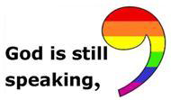 Are you listening?

- Wally and Gretchen Brown Think about a visit, or a meal (gluten free/no dairy), or a card to cheer up Gretchen.
- Laila Washburn Since her fall this year, Laila has moved to Summer Hill Assisted Living in Peterborough. The transition was hard at first, but Laila has had many changes over her lifetime which she takes in stride, and she is making the most of this one. Her daughter says she has more company than ever! Her kind manner will win over all who meet her there. She loves company, and cards. At 98, everyday is treasured. Laila Washburn, Summer Hill, 183 Old Dublin Rd, Peterborough, NH 03458. Call ahead if you have questions. 924-6238
- During the holiday season, we often especially miss our loved ones who are no longer with us. We have a “Memory Tree” in the sanctuary. Please add your pictures, or memories for all to share. Catherine Schwenk, Judy Wilkins, our Rev Veronica, Dotsie Milbrandt, Edie Fallon have all lost loved ones fairly recently. And now Eileen and Fred Cuda have also suffered a loss as Eileen’s brother died unexpectedly. Your prayers have power, as do your thoughts and courtesies!

The primary purpose of prayer is not to make requests. The primary purpose is to praise, to sing, to chant. Because the essence of prayer is a song, and man (and woman) cannot live without a song. Prayer may not save us. But prayer may make us worthy of being saved. Abraham Joshua Heschel

Annual Pledge Drive Oct. 28, 2017
What do you get in return for every dollar you pledge?
You support a pastorship of preaching, teaching, counseling, visitation, and Christian sacraments. You see children grow in knowledge and character through our Sunday school and nursery. You are maintaining a set of historical buildings that are a cornerstone to our town and which provide a wonderful space for worship, weddings, and memorial services. You are providing music to our souls at each worship service. You are enabling community events of dinners and coffee houses to introduce us to new neighbors and to unite us with old friends. You provide a safe space to worship God and a place for people to minister to each other. We are proud to be a small congregation that does much. We have numerous small ministries in addition to those already mentioned; helping with the Nashua soup kitchen, providing countless prayer shawls for the sick and bereaved, maintaining a Diaconate fund that is available for families in need. Year to date giving to St. Vincent de Paul and UCC special offerings is over $4000.
We are all in this congregational life together and when we all contribute our fair share of time and money, we can accomplish much. Life goes in cycles; those who are in the abundance side of the cycle can pull a little harder for those who are suffering through the adversities of life. Let us hope that when we are in the difficult times, others will be available to pull a little harder in our place. In summary, we are investing in our own spiritual growth and in the spiritual growth of our local towns. Thank you for your past generosity. Thank you for your future generosity.
Church Council Members, Darrell Scott, Treasurer Reverend Veronica Don, Dotsie Millbrandt, Council Chair Karin Eisenhaure Secretary, Mike Goen Trustee Chair, Marlene Damary Christian Education, Judy Wilkins Gifts and Nomination, Michelle Scott Diaconate Chair
Please return a pledge card to the treasurer in the collection plate or in person. Pledges can also be received over the phone or by email, church # 878-1684, Darrell Scott 878-1680 or email scottdarrell39@gmail.com

